The Effect of Battle Circumstances on
Fitting Lanchester Equations to the Battle of Kursk
Thomas W. Lucas
Operations Research Department,
Naval Postgraduate School, Monterey, CA 93943
twlucas@nps.edu
John A. Dinges
United States Army Command and General Staff College
Fort Leavenworth, Kansas 66027
john.dinges@us.army.mil

ABSTRACT
Lanchester equations and their extensions are widely used in calculating aggregate attrition in models of warfare. However, due to a lack of high-quality battle data, few validation studies have had strong findings. In particular, there are only a few data sets containing detailed, two-sided, time-phased information. This study uses the Center for Army Analysis’s recently compiled Kursk Data Base to examine how well the various Lanchester laws fit the southern front of the Battle of Kursk. The Kursk Data Base is unique in that it records the daily combat status of all of the division-level units as: (1) all combat forces in the campaign; (2) all combat forces within contact; and (3) combat forces within contact that are actively engaged. We find that much more of the variation in casualties during the Battle of Kursk is explained by the status of the forces considered and the phases of the battle than by the Lanchester variant used. Specifically, we obtain substantially better fits when we use only the forces that are actively fighting. An additional improvement in fit is gained by breaking the battle into its natural phases. Finally, when comparing fits among the basic laws, we observe that Lanchester’s linear law fits these aggregate data better than the logarithmic law does and much better than the square law does.

APPLICATION AREA: Land & Expeditionary Warfare; Modeling, Simulation, & Gaming
OR METHODOLOGY: Nonlinear Optimization, Nonparametric Statistics

1. INTRODUCTION
Models of warfare provide information to assist decision-makers in making and justifying decisions that involve billions of dollars and impact many lives. One complicated characteristic of most warfare models is the representation of the decrease in force levels over time, commonly referred to as attrition. In the year that World War I began, British inventor F.W. Lanchester (1914) proposed a set of differential equations in order to quantitatively justify the importance of force concentration on the modern battlefield. Lanchester believed that “ancient combat” consisted of a series of one-on-one duels between individual soldiers. Therefore, the combatants’ force levels had no effect on the exchange ratio. However, Lanchester hypothesized that in “modern combat” forces have the capability of aiming fire from different locations onto a single target. In this case, each side’s casualty rate is proportional to the number of enemy firers, and an obvious advantage exists in massing forces. For these two situations, Lanchester worked out state equations that relate the two side’s force levels over time. Since then, other variants and extensions have been proposed, including one known as the logarithmic law, in which a force’s losses are proportional to its own numerical strength (see Peterson, 1967).
In an effort to realistically model attrition processes, many aggregate-level combat models employ Lanchester-type equations and their derivatives. As one would imagine, with so much relying on Lanchester’s equations, there have been several efforts using historical combat data to validate them and to determine which law, if any, best fits the data. Unfortunately, there have been few clear results.
Using the Center for Army Analysis’s (CAA) recently developed Kursk Data Base (KDB), this paper explores the validity of Lanchester equations as a model of the manpower attrition in the Battle of Kursk in World War II. In previous studies using historical data to validate Lanchester equations, the authors make no distinction between those forces that are actually engaged and those that are not engaged. However, the KDB uniquely distinguishes between all combat units, all combat units within contact, and all combat units within contact and engaged. Quite possibly, Lanchester equations may prove more applicable to one of these data types. Such a finding could prove useful in determining how best to utilize Lanchester-based equations in combat, training, and analysis. In order to examine this, we construct three separate data sets from the KDB, using names borrowed from Gozel (2000). These data sets divide the KDB into three inclusive categories: (1) all combat unit data (ACUD); (2) combat unit data for those units that are within contact (CCUD); and (3) combat unit data for only those units that are actually fighting (FCUD). The Center for Army Analysis (1998) defines within contact units as those units “within contact of the front line.” The ones we call fighting units are those that are “actively engaged in combat…[either by] directly participating in an attack or being assaulted by an enemy.” Using these three categories, we answer two key questions in this paper: (1) Which, if any, of the basic Lanchester laws (square, linear, and logarithmic) best fit the highly detailed Kursk battle data? (2) How is the fit affected by the status of the forces considered and the phases of the battle?
The paper is organized as follows. Section 2 defines a generalized form of Lanchester’s homogeneous attrition equations and highlights some of the efforts to validate them—with an emphasis on the very few Lanchester attrition studies using
time-phased data. A brief overview of the Battle of Kursk, often called the greatest tank battle in history, is provided in Section 3. Section 4 presents and discusses the three inclusive data sets that we use in our analysis. In Section 5, we examine how well a variety of different Lanchester models fit the various data sets. A concluding section summarizes the paper’s key findings.

2. BACKGROUND
A generalized form of the Lanchester model, as specified by Bracken (1995), is:
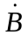(t) = a(d or 1/d)R(t)^{p}B(t)^{q}, (2.1)
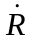(t) = b(d or 1/d)B(t)^{p}R(t)^{q}, (2.2)
where B(t) and R(t) are the strengths of the Blue and Red forces at time t,(t) and(t) are the rates at which the Blue and Red forces are being attrited at time t, a and b are attrition rate parameters, p is the exponent parameter of the attacking force, q is the exponent parameter of the defending force, and d is a tactical parameter that adjusts the attrition to the defender by a factor of d and the attacker by a factor of 1/d. Initial force sizes are represented by B(0) and R(0) and, when numerically calculated with time step ∆t, are incrementally decreased as follows: B(t + ∆t) = B(t) – ∆t(t) and
R(t + ∆t) = R(t) – ∆t(t).
Three specific variations of these equations are of particular interest due to their intuitive nature and simplicity. A brief introduction to them follows. A comprehensive treatment can be found in Taylor (1983).
Lanchester (1914) stated that “the conditions of ancient warfare” made it “not possible…to bring other than approximately equal numbers of men into the actual fighting line.” Consequently, “one man would ordinarily find himself opposed to one man,”—i.e., the battle was essentially a collection of one-on-one duels. While not explicitly written down, Lanchester’s model for ancient combat assumes that the exchange ratio (i.e., (t)/(t)) is a constant, independent of the force levels. This occurs whenever p − q = 0 in Equations (2.1) and (2.2). In such a case, the state equation relating force levels at time t is b(B(0) – B(t)) = a(R(0) – R(t)). Hence, this is commonly known as Lanchester’s linear law. The most commonly used linear law is when
p = q = 1. In such a case, the attrition is proportional to both the number of shooters and targets. This corresponds to a situation in which Lanchester described as “firing into the brown.” That is, rather than aiming at specific targets, the firers shoot randomly into an area containing the targets. Consequently, this variant is frequently referred to as
“area fire” and is often used to model indirect fire (see Taylor, 1983).
Lanchester contrasted “ancient conditions” with what he called “modern conditions.” Under modern conditions he theorized that the firepower of a force could be concentrated on the enemy; hence a side’s attrition “will be directly proportional to the numerical strength of the opposing force.” That is, p = 1 and q = 0. Under this formulation, or more generally when p − q = 1, the state equation relating force levels at time t is b(B(0)²–B(t)²) = a(R(0)²–R(t)²). Consequently, this formulation is known as Lanchester’s square law and is often referred to as aimed fire. Lanchester showed the added importance of force size (relative to force quality) if attrition follows the square law. He called this “the principle of concentration.” Of course, the conditions underlying these formulations are never fully realized. For example, the ability to perfectly concentrate fires requires an unobtainable degree of coordination. Nonetheless, using some historical examples, Lanchester (1914) concludes that it is an “important truth” that “the fighting strength of a force can be represented by the square of its numerical strength.” His square law is probably the most used of the various Lanchester variants.
A third commonly used version, which Lanchester did not address, is when p = 0 and q = 1 (or, more generally, when p – q = –1). In these situations, the state equation is b(ln(B(0)/B(t))) = a(ln(R(0)/R(t))), and the model is called the logarithmic law. In this seemingly counterintuitive set-up, each side’s losses are proportional to their own force size. This can represent situations in which the primary causes of casualties are disease, desertion, equipment failures, or other non-battle losses. In addition, this may apply to battles in which the casualties are more a function of the number of targets that are located and attacked. For example, Fricker (1998) hypothesized that during
Desert Storm, “given the Allied force size, Iraqi casualties [may have been] simply a function of how many Iraqi ‘targets’ existed.” Pederson (1967), who is credited with developing this model, observed this phenomenon empirically in small unit tank duels during World War II. Weiss (1963) found a similar relationship in aerial combat, and posited that since most kills were made by only a small number of pilots, that perhaps “doubling the enemy doubles the number of sheep for the wolf.”
This paper focuses on the three Lanchester laws just described—all special cases of Equations (2.1) and (2.2), in which the losses suffered by each side have the same functional form. While we do not consider them in this research, there are asymmetric extensions to Lanchester’s work that deserve mention. Typically, these involve situations in which one side has an information advantage. For example, Deitchman (1962) modeled guerrilla warfare as one in which one side (an ambushing force) attrits the other side with aimed fire, while suffering casualties due to area fire. More recently, Darilek et al. (2001) study a family of asymmetric models that they call Lanchester information laws.
Previous studies on the validation of Lanchester equations using historical data have been limited due to the dearth of high-quality data sets. These studies fall into two categories: (1) before and after data for a large number of battles; and (2) the daily force levels and casualties within an individual battle. We discuss the former first—a more quantitative review of these data sets can be found in Speight (2002).
In a remarkable series of papers, Osipov (1915), independent of Lanchester’s work, derived and empirically tested Lanchester’s square law and related laws. Using data on 38 battles, ranging from Austerlitz in 1805 to Mukden in 1905, Osipov found that a mixed square-linear law empirically “explains the dependence of casualties on numerical strength much better than [the square law].” However, he also stated that the historical analysis “cannot give conclusive demonstration of the theory.” Using data on 1,493 battles from 1618 to 1905, Willard (1962) concluded that “Lanchester’s square law is the poorest among poor alternative choices.” Weiss (1966), integrating a series of U.S. Civil War data sets, found that “in battles other than attacks on fortified lines the casualty ratios appeared to be independent of the force ratios”—as one would get with the linear law. In attacks of fortified positions, however, he found that “the losses of the attacker were proportional to the force size of the defender”—as would be produced by the square law. Applying Willard’s approach to 60 World War II battles, Fain (1977) found that the best-fitting Lanchester model was somewhere between a linear and a logarithmic law. And, in perhaps the most complete study of before and after battle data, Hartley (2001), using 857 battles from 280 BC through 1973 (with fewer than 100 from pre-1756) determined an empirical “law of attrition” from Equations (2.1) and (2.2) as p = .45 and
q = .75. This, again, is a mixed linear-logarithmic law.
When people talk about a “law of aggregate attrition,” it is with respect to the central tendencies of the exponent parameters p and q over the ensemble of battles that have occurred. Clearly, the ability to mass fires depends on the forces, their equipment, the terrain, the forces’ postures, etc. Furthermore, the attrition coefficients, a and b, are certain to wax and wane, even within a battle, and vary from battle to battle by a tremendous amount—as there are many battles in which only a small percentage of forces are attrited and some in which there is near total annihilation. As Hartley and Helmbold (1995) write:
The Lanchester coefficients are often referred to as constants and it is easy to forget that this means only that the coefficients are assumed to be constant for a given battle or portion of a campaign.
This complicates our analysis in studies using before and after battle data because Equations (2.1) and (2.2) have five parameters in them (a, b, p, q, and d), and the two data points result in an over-determined system of equations, with an infinite number of solutions, for any individual battle. Thus, the results found by investigating multiple battles have been either mostly qualitative in nature or have relied on strong, untested assumptions on the model parameters—such as a = b and is constant over time
(Willard, 1967). Because of this, Hartley and Helmbold (1995) write that “[u]nless we are able to procure [more detailed two-sided, time-phased battle data sets] we will not be able to validate the homogeneous square law (or any other attrition law).”
Using daily manpower data for 36 days of the Battle of Iwo Jima, Engle (1954) conducted the first analysis that used time-phased battle data. Using daily force and casualty levels for the attacking U.S. Marines and before and after information on the defending Japanese (who died almost to the last man), he visually showed that the actual U.S. losses reasonably tracked what was obtained by a fitted square law. However, Engle provided no goodness-of-fit measure to quantitatively assess the match and noted that “other forms of Lanchester’s equations might apply to the Battle of Iwo Jima as well.” Busse (1971) analyzed 20 days of manpower battle data from the Inchon-Seoul campaign of the Korean War. He also visually compared how the daily casualties matched what one would expect from the square law, though he found that the homogeneous square law did not fit well. Using the same data, Hartley and Helmbold (1995) showed how visual comparisons can be misleading and, by applying statistical tests to the data, concluded that: (1) “any square law effects are largely masked by other factors”; and (2) the data better fit a set of three separate battles (one distinct battle every six or seven days).
The Iwo Jima and Inchon-Seoul data sets were the only time-phased data sets that had been analyzed with respect to Lanchester’s equations until CAA developed detailed time-phased data on the World War II battles of Ardennes and Kursk (see Data Memory Systems (1990) and Center for Army Analysis (1998)). Moreover, while the previous two data sets contain only manpower data, and reliably for only one side, the CAA databases have daily on-hand and loss data by weapon system type on scores of division-level units for both sides.
There have been a series of validation studies, yielding conflicting results, based on the Ardennes data set. Bracken (1995) formulated four models for the Ardennes campaign using Equations (2.1) and (2.2). He also developed a homogeneous data set representing the combined strength of manpower, tanks, armored personnel carriers, and artillery. By means of a constrained grid search, Bracken estimated the parameters (a, b, d, p, q) that minimized the sum of the squared residuals (SSR) [see Equation (2.3)] for the first 10 days of the of the Ardennes campaign with and without the defensive parameter (d) for combat forces and for total forces. Among other conclusions, Bracken found that “the Lanchester linear equation fits the [Ardennes] campaign.”
SSR = 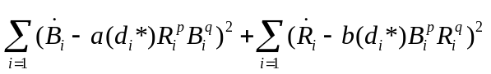 (2.3)
Where:
i indexes the first 10 days of the battle, and
d_{i}* = d if the side (Red or Blue) is on the defensive on day i and 1/d if the side is on the offensive. If neither or both sides are clearly on the offensive, then d_{i}* = 1.
Fricker (1998) followed up Bracken’s study of the Ardennes campaign by applying linear regression to logarithmically transformed data to determine each of the parameters that resulted in the best fit (i.e., minimized SSR) when compared to the actual data for all 33 days of the Ardennes data set. Fricker also included air sortie data and employed an algorithm that reconfigured daily force levels “to estimate initial force sizes that reflect all of the troops that eventually fought in the campaign and then subtract the casualty attrition from this total on a daily basis.” Fricker found that neither the linear nor the square law fit well. He concluded that the force’s losses were more a function of their own force level than of their opponent’s force level, as one would get from the logarithmic law.
Wiper et al. (2000) used Bayesian methods to reexamine Bracken’s and Fricker’s Ardennes data. Their model is more general in that it uses two defensive parameters, a separate one for each side. Using Gibbs sampling, they estimate several posterior quantities of interest, in particular the means of p and q. Using Bayes factors, they conclude that “the logarithmic law fits best [and] the linear laws cannot be rejected, but the square law does seem implausible.” However, they show that their results are quite sensitive to the prior selected. Lucas and Turkes (2004) found that the SSR surfaces are relatively flat—thus explaining why different assumptions and fitting techniques yield such diverse results. Moreover, they found:
[T]here is little difference in fits between the square, linear, and logarithmic Lanchester laws—with those observed differences explainable simply by chance variation. . . . More importantly . . . no constant attrition coefficient generalized Lanchester model [fits] very well . . . [with] much more of the variation in casualties . . . explained by the phases of the battle.
Looking across the breadth of these studies, we find very few strong or consensus results. In fact, nearly two decades ago, Schneider (1985), in a review of “several attempts to verify Lanchester’s equations in the light of military history,” concluded that, “[a]t best, one can say that the results of these studies have been contradictory.” Subsequent studies seem not to have improved the situation.

3. HISTORICAL OVERVIEW OF THE BATTLE OF KURSK
Following its disastrous defeat at Stalingrad in the winter of 1942–43, the German military’s offensive operations on the Eastern Front came to a near standstill. Desperately seeking to regain lost momentum, Adolf Hitler set his sights on the Kursk salient, which extended nearly 150 km to the west and was nearly 200 km wide. This salient was the dominant feature on the front and offered the perfect target for German tactics that had proved so successful in the past—encircling vast Soviet armies and destroying them in the process.
The German plan, named Operation Citadel, consisted of a classic pincer maneuver. Field Marshal Gunther von Kluge’s Army Group Center, led by General Model’s Ninth Army, was to attack from the northern flank of the bulge and drive toward the town of Kursk. Here, it would link up with General Hoth’s 4th Panzer Army from Field Marshal Erich von Manstein’s Army Group South, which was attacking from the southern flank. If successful, the Germans would encircle and destroy five Soviet armies, forcing the Soviets to delay their operations and allowing the German armed forces to regain the initiative. Just days before the offensive was launched, Hitler declared:
This attack is of decisive importance. It must succeed, and it must do so rapidly and convincingly. It must secure for us the initiative. . . . The victory of Kursk must be a blazing torch to the world (Tsouras, 1992).
Due to extensive German delays and a fruitful intelligence-gathering effort, the Soviets were well prepared for the German assault. They worked feverishly to prepare a formidable defensive front, consisting of up to seven defensive lines with anti-tank strong points, anti-tank ditches, and extensive belts of minefields. The Soviets’ knowledge of the German plan was so extensive that they knew the exact day that Germany would launch its assault. In fact, an hour before the German attack finally began on 5 July 1943, the Soviets launched a pre-emptive artillery barrage on known enemy assembly areas.
Although the barrage caused a momentary delay, the Germans began the assault at 0700 hours. In the North, Model’s Ninth Army struggled with the prepared Soviet positions for several days, gaining only six miles of ground before stalling. With no hope of breaking the formidable Soviet defense, the Germans became mired in a war of attrition and were eventually thrown back in disarray. However, in the South, a different story was developing. German forces made significant daily gains and, by 11 July, were in position to capture the town of Prokhorovka. A victory here would enable the Germans to establish a bridgehead over the Psel River, the last natural barrier between the Germans and Kursk. Recognizing the importance of Prokhorovka, the Soviets deployed their strategic armored reserve, the Fifth Guards Tank Army, to meet the Germans head-on.
The two forces collided on 12 July in what has become known as the “largest tank battle ever fought,” with 483 SS tanks fighting 525 Soviet tanks. At the end of the day, the Soviets had lost 375 tanks, while the German losses numbered only 92. Despite this disparity, von Manstein’s drive to Kursk was stopped by the sheer impact of the battle. Combined with the Soviet offensive in the North and the Allied invasion of Sicily two days later, Hitler decided to abruptly cancel Operation Citadel, despite the pleas of
von Manstein, who wrote: “[T]he last German offensive in the East ended in a fiasco, even though the enemy . . . suffered four times their losses” (Glantz, 1999). The Germans fell back into defensive positions, while the Soviets began a series of counterattacks, regaining all lost ground by 23 July. The battle to regain momentum in the East had been lost, and the Germans would never again mount a significant offensive against the Red Army. (See Wilson (2004) and the references in this section for more on the Battle of Kursk.)

4. The BATTLE OF kursk data
The Kursk Data Base (KDB) is documented in the Kursk Operation Simulation and Validation Exercise – Phase II (KOSAVE II) report (Center for Army Analysis, 1998) and is used to construct the databases we analyze in this paper. The inputs to the KBD were provided by The Dupuy Institute using archived military records in Germany and Russia. The Dupuy Institute is one of the premier military historical research organizations in the world. More information on them and their numerous databases and publications can be found at http://www.dupuyinstitute.org/index.htm [accessed
17 March 2004]. The Kursk and Ardennes data sets were constructed to “assess and improve combat model credibility” (Center for Army Analysis, 1998). Our use of the data is similar to CAA’s, though with a much simpler model.
The KDB is highly detailed, containing two-sided data that are time-phased daily from 4 July 1943 through 18 July 1943. The data are taken from the southern front of the Battle of Kursk and are organized, at the division level, into the following sections: units and combat posture status; personnel status and casualties; weapons status and losses; ammunition status; aircraft sortie status; and geographic unit positions and progress. While the KDB covers 15 days, since the battle didn’t really begin until day two of the database, our analysis considers only the last 14 days.
In the KDB, manpower represents combat manpower, which is composed of all infantry, armor, and artillery forces—including headquarters units. Logistics and support personnel are not in the database. Daily combat manpower is calculated by summing the “On-Hand” (OH) manpower totals in the KOSAVE II report for all combat and headquarters units. The KDB organizes casualties into four separate categories: killed, wounded, captured/missing in action, and disease and nonbattle injuries. Daily combat losses are calculated by summing these categories. The fighting status of combat units is also attained from the KOSAVE II report, which specifies the status (fighting, within contact but not actively fighting, and not within contact) for each combat unit on each day of the battle. Using this, the database is divided into three inclusive sets: all combat unit data (ACUD); combat unit data for those units that are within contact (CCUD); and combat unit data for only those units that are actually fighting (FCUD).
Tables 1 and 2 show the ACUD, CCUD, and FCUD manpower data sets, on-hand and losses, for the Germans and Soviets. Note that the Soviets’ numerical advantage decreases as the degree of engagement status becomes more refined. For example, using the ACUD data, we see that the Germans were severely outnumbered when they attacked, and throughout the battle. However, the Germans continually had a higher proportion of their forces in contact and engaged. For example, on day one, in the FCUD data, the German’s outnumbered the Soviets by nearly three to one. We also see that, with the ACUD data, the combat forces on both sides (particularly the Soviets) declined steadily during the battle. On the other hand, there is much more variability in force levels in the CCUD and FCUD data sets. During the course of the battle, casualties generally decreased, particularly for the Germans. It is important to emphasize that correlations among the variables, and their correlations with time, complicate the analysis by confounding relationships. For example, what is the primary cause of the decrease in German casualties? Is it the decrease in the Soviet force level, the decrease in the German force level, a combination of both, and/or other factors that are correlated with time?
Table 1. Daily German on-hand manpower and losses as a function of contact and fighting status.
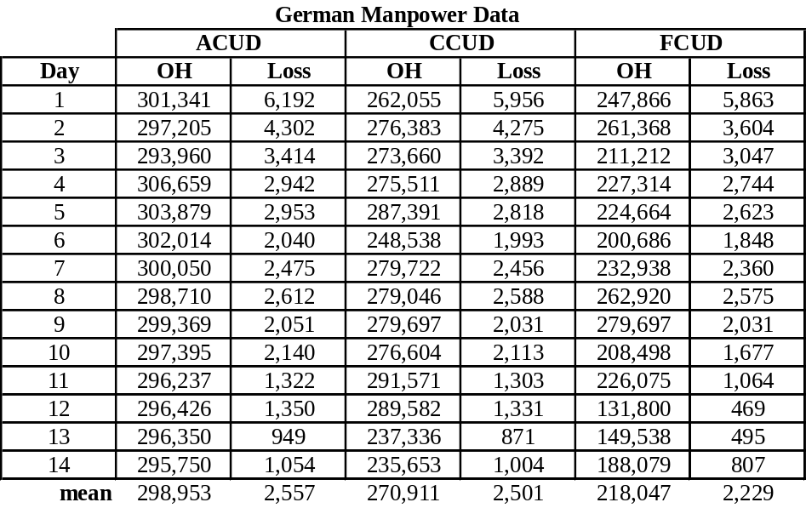

Table 2. Daily Soviet on-hand manpower and losses as a function of contact and fighting status.
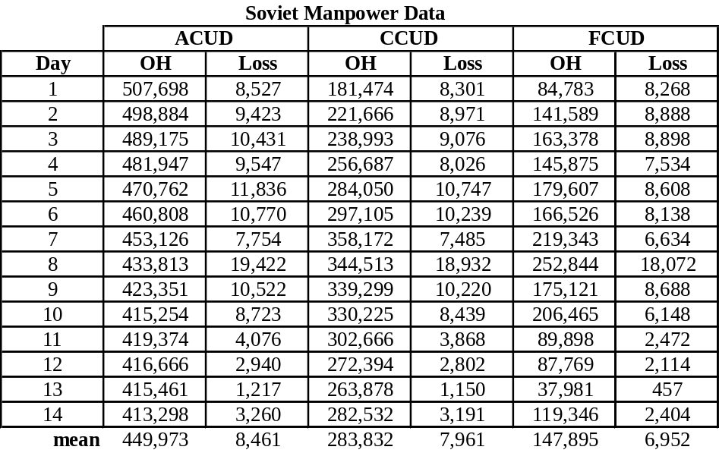

5. Lanchester and the battle of Kursk AS A FUNCTION OF THE UNITs’ COMBAT STATUS
This section investigates how well a variety of homogeneous constant coefficient Lanchester laws fit the all combat unit data (ACUD), within contact combat unit data (CCUD), and the fighting combat unit data (FCUD). Note: Lucas and Turkes (2004) found that the results are extremely insensitive to Bracken’s defense parameter d; hence we do not include it in our analysis.
5.1 Estimation Procedure
Given the values in Tables 1 and 2, we determine what values of the parameters (a, b, p, q) best fit the data. Of course, our focus is on p and q, for they relate to the Lanchester laws of attrition. In particular, we are interested in whether the square, linear, or logarithmic laws fit well and how this depends on the forces used in the calculations. Our measure of fit, taken from Dinges (2001), is the R² statistic. R² measures the proportion of the squared deviation explained by the model over that obtained by using the average losses. The R² value is a linear function of SSR and is calculated with the following formulas:
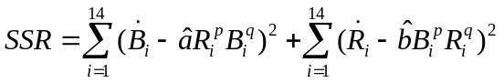, (5.1)
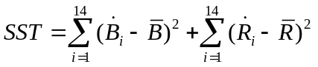, and (5.2)
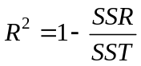. (5.3)
Where: 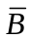 and 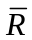 are the mean daily losses for the Soviets and Germans, respectively, and and are the estimated attrition coefficients.
A lower SSR value or a greater R² value indicates a better fit. A perfect fit would yield an R² of one. An R² of zero means that the model adds nothing to the fit above and beyond using the mean daily losses as the estimated attrition. Given p and q values, the attrition coefficients ( and ) that maximize R² can be easily found by regression through the origin (see Equations (5.4) and (5.5)):
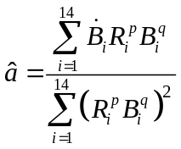, and (5.4)
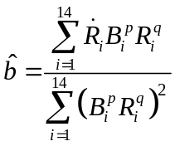. (5.5)
In addition, by varying p and q and plotting the contours of the maximum R² as a function of p and q, we can get an understanding of how the possible pairs of Lanchester exponent parameters fit the battle. Furthermore, from these contours, we can visually identify the best-fitting (i.e., optimal) values of p and q.
5.2 The Basic Lanchester Laws
Using the three inclusive combat status data sets, the best-fitting Lanchester square, linear, and logarithmic laws are calculated using the procedure specified in Section 5.1. The results are summarized in Table 3. We see that the FCUD data provide much better fits for all three laws. Moreover, all of the fits using the ACUD and CCUD data sets are only slightly better than what would be obtained by using the mean losses as estimates, as evidenced by the near-zero R² values. A comparison of the goodness of fits within the FCUD data shows that the linear law best fits the data—with an R² value of .622. Thus, 62 percent of the squared variation in the data can be explained by the linear law model. The logarithmic law provides the next-best fit, with an R² of .535. It is interesting to note that, for such highly aggregated data, Lanchester’s law for modern combat—i.e., the square law—is the poorest, by far, of the FCUD fits, with an R² of just under .3. In addition, by examining the coefficients of the various data sets and models, the Germans are estimated to be anywhere from 2.21 to 4.90 times as effective, per soldier, as the Soviets. This compares favorably with Dupuy’s estimate of 2.68
(Dupuy, 1985).
Table 3. Best-fitting basic Lanchester law fits for the three combat status data sets.
Data Set | Lanchester Law |  |  | R²
 | Square | .0284 | .0058 | .034
ACUD | Linear | 6.3510⁻⁸ | 1.9610⁻⁸ | .110
 | Logarithmic | .0190 | .0086 | .079
 | Square | .0296 | .0081 | .014
CCUD | Linear | 1.0310⁻⁷ | 2.9710⁻⁸ | .064
 | Logarithmic | .0279 | .0092 | .068
 | Square | .0333 | .0137 | .298
FCUD | Linear | 2.1910⁻⁷ | 5.8910⁻⁸ | .622
 | Logarithmic | .0481 | .0106 | .535

5.3 The Best-Fitting Lanchester Law
In the previous subsection we restricted our search to the basic Lanchester models and found that the best-fitting of them is the linear law on the FCUD data. The question remains: what values of p and q (i.e., which generalized Lanchester law) gives the best fit to the Kursk data? Since the FCUD data fit so much better than the CCUD and ACUD data, we focus on them. In order to answer this question, we need to maximize R² over four parameters (a, b, p, and q). We do so as follows: for given p and q, use Equations (5.4) and (5.5) to find and , and the corresponding maximum R², from Equation (5.3). We do this for a grid of p and q values and plot the contours of the maximum R² as a function of p and q. It turns out that the response (R²) is a smooth function of p and q—with an easily identifiable unique mode (see Figure 1). Moreover, not only can we visually assess where the optimum occurs, but we also obtain an understanding of how the surface of Lanchester exponent parameters fits the battle. The optimum p and q are found by a grid search, with three decimal places of precision, over the visually identified area where the optimum occurs. The best-fitting Lanchester law is p = 1.156 and
q = 1.000, with an R² of .624. This is quite close to the linear law. In fact, the difference in goodness of fit (i.e., .002) is negligible.
We see from Figure 1 that the maximum R² surface is relatively flat with respect to p and q. Specifically, the maximum R² can be within roughly 10 percent of the optimum for q values from about .5 through 1.5 and p values from below zero to above two. The contours drop much faster as q moves away from the optimum than when p does. This results in the logarithmic law having a much better fit than the square law.
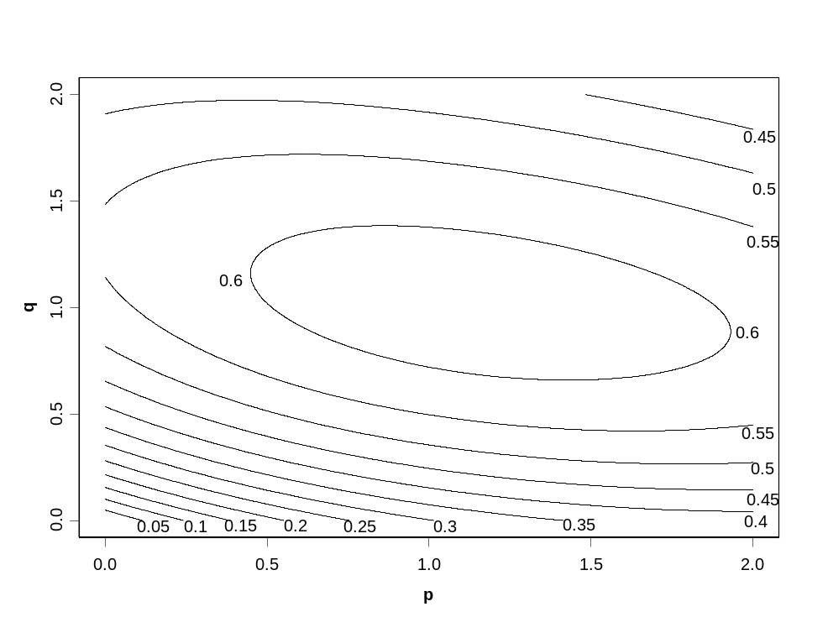
Figure 1. Contour plot of the maximum R² as a function of exponent parameters p and q.
While the contours are not shown, since the fits are so much poorer, the optimum Lanchester law is: for ACUD, p = 7.37 and q = 1.78, with an R² of .221; and for CCUD, p = 0.40 and q = 0.93, with an R² of .071. These were determined by two decimal precision grid searches around the visually obtained optimums. We see that even the optimum fits are quite poor for these data sets. Moreover, the optimal ACUD parameters are highly implausible, with a p of 7.37 implying that doubling one’s force increases the opponent’s attrition by a factor of 165.4.
5.4 Assessing Differences in Fits
All of the above comparisons involved point estimates on a single event. In this subsection we use the bootstrap (see Efron and Tibshirani, 1993) to assess the significance in differences in maximum R² values between the Lanchester models for the FCUD data. Since all battles are nonrepeatable events, and we only get one observation, we must carefully specify what we mean by significant differences. Towards that end, we define the natural variation as that which would occur (due to the inherent randomness of combat) if many essentially identical forces fought similar 14-day battles.
In fitting the Lanchester models above, the 14 days of the battle are essentially treated as 14 separate one-day battles—as this is the resolution of the data. The variability in the maximum R² for each of the basic and optimum laws is estimated nonparametrically by resampling the empirical daily attrition coefficients from the 14 days. That is, for each of the Lanchester laws, we calculate 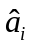 and for i = 1, 2, …, 14; where and are the daily attrition parameters that achieve equality in Equations (2.1) and (2.2). The 14 (,) pairs are the attrition rates that actually occurred in the battle (according to the KDB) if the Lanchester law being used (to generate the resampled battles) held exactly. A “bootstrap battle” is generated by sampling with replacement from the 14 (,) pairs and generating 14 daily “bootstrap casualties” by using the 14 resampled (,) pairs and the actual force levels.
Using the above procedure for the three basic Lanchester laws and the optimum Lanchester fit, 10,000 bootstrap battles (from the 14¹⁴ possible ones) are independently generated. In each of the 10,000 bootstrap battles we find the best-fitting model (maximum R²) over a and b, as before. The estimated standard errors (i.e., the standard deviations of the bootstrap samples) of the maximum R² for the square, linear, logarithmic, and optimum laws are, respectively, .131, .177, .197, and .174. We see that, except for the square law, the differences in maximum R² values are smaller than the estimated standard errors associated with them. However, there are substantial positive correlations between the maximum R² values for the different Lanchester models. That is, bootstrap battles that fit one law well also tend to fit the other laws well. In our resampling, we use the same resampled days for all four of the Lanchester laws that are compared. Therefore, from our 10,000 bootstrap battles, we can count how often one law fits better than another. This information is shown in Table 4.
Table 4. Proportion of FCUD bootstrap battles (out of 10,000) in which the Lanchester law specified by the row fit better (i.e., had a higher R²) than the law specified by the column.
Lanchester Law | Square | Linear | Logarithmic
Linear | .9943 | — | —
Logarithmic | .9187 | .0548 | —
Optimum fit | .9968 | .7270 | .9275
We see that the best fit almost always comes from either the optimum law (as fit to the original data) or the linear law. Unfortunately, neither law is clearly better, as there is a reasonable chance (over one in four) that, in our bootstrap battles, the linear law actually has a higher maximum R² value than the optimum law. We do, however, get a reasonably strong ordering of the basic laws. The linear law fits the data better than the logarithmic law in nearly 95 percent of the bootstrap battles. Furthermore, the logarithmic law fits better than the square law almost 92 percent of the time.
5.5 Battle Phases
One of the assumptions that we (and previous researchers) made when fitting the above models is that the attrition coefficients (a and b) are constant during the battle. Of course, we know that, even if a Lanchester law held exactly, these coefficients surely vary (at least) day by day. Ideally, we would estimate daily attrition parameters to take into account the unique factors associated with each day in the data set. Unfortunately, this results in a perfect fit for any Lanchester law and, thus, is not helpful. However, we know from historical accounts that there were several phases in the battle in which the attrition coefficients should be relatively constant. Specifically, at the start of the campaign, the Germans generally attacked prepared defenses. Gradually, as they made progress, they engaged an increasing number of forces in a hasty defense. On the eighth day of fighting—i.e., “the bloodbath at Prokhorovka”—the Soviets counterattacked. During the remaining six days, the Soviets were increasingly on the offensive, and the battle intensity faded.
Figure 2 displays the actual and estimated (by the model) Soviet and German losses for the best-fitting constant attrition coefficient Lanchester linear law using the FCUD data. There are clear patterns in the differences between the estimated and actual losses. Early in the campaign, and particularly on the first day, the actual losses are uniformly higher than the estimated losses for both sides. For the Soviets, from day seven on (with the exception of day eight) the actual losses are less than the fitted ones. Similarly, for the Germans, from day six until the battle’s end (with the exception of day 13) the actual losses are smaller than the estimated ones. This suggests that the attrition rates varied as a function of which forces were attacking, the defensive postures, and the length of the battle—as one would expect.
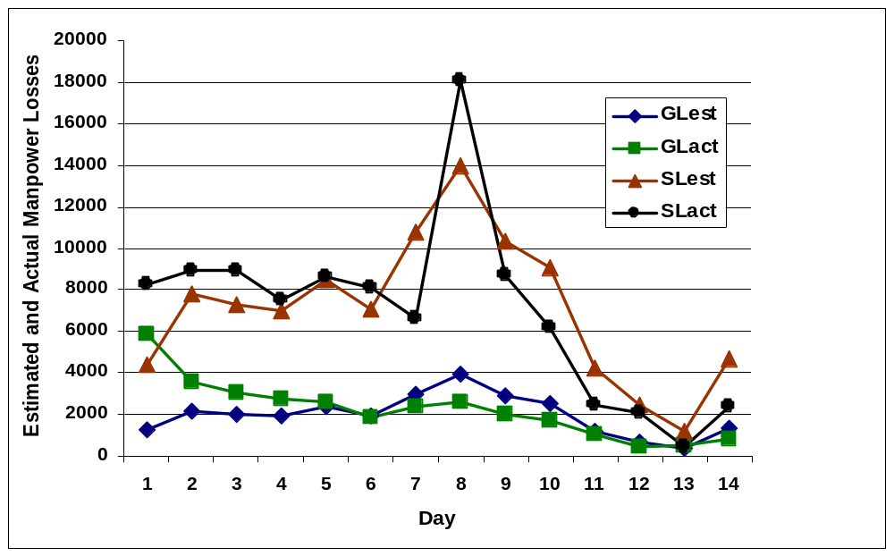Figure 2. A comparison of the estimated losses (Soviets = SLest and Germans = GLest) with the actual losses (Soviets = SLact and Germans = GLact) for the best-fitting constant attrition coefficient Lanchester linear law using the FCUD data.
The patterns in the differences between the model fits and the data suggest that we can improve the goodness of the fits if we fit separate attrition coefficients to the major phases of the battle—as Hartley and Helmbold (1995) did with the Inchon-Seoul data. The extra parameters guarantee a higher R² value. The issue is whether or not the improvement in fit justifies the reduction in parsimony. One natural partitioning of the Battle of Kursk into four phases is as follows. The first phase consists of the first two days of the campaign, with the Germans primarily attacking prepared defenses. The second phase, with the Germans pressing the attack against less-prepared defenses, contains days three through seven. The historic eighth day is unique and is considered a phase by itself. Of course, since this phase is only a single day, there is a perfect fit
(i.e., no residual error); thus, this removes the (outlying) eighth day from the fits. The fourth and last phase is days nine through 14.
The four-phase model fits are much better than what is obtained with the constant attrition coefficient models—for all three data sets. For both the ACUD and CCUD data, all of the basic Lanchester laws achieve R² values of between .732 and .744. While these fits are dramatically better than the earlier fits, almost all of the improvement comes from partitioning the battle into the four phases. The R² that is obtained by using the mean loss in each phase, for each side, as the sides’ estimated losses, is .734 and .730, respectively, for the ACUD and CCUD data. As before, we get better fits from the FCUD data, with the R² values from the basic Lanchester laws ranging from .836 to .860. The FCUD phase mean model has an R² of .796.
Looking across all the data sets, we see that the additional improvement in fit from the Lanchester laws is small relative to the improvement achieved by using phases (i.e., adjusting for battle intensity, posture, terrain, etc.). This suggests that there is more to be gained from accurately accounting for the phases of a battle than from ensuring that one uses the “correct” Lanchester law. That is, with the right coefficients, any Lanchester phase-fitted model fits considerably better than the best-fitting constant attrition coefficient model. Of course, determining battle phases is easier to do in hindsight than when predicting potential future battle outcomes. Also, one must be wary of over-fitting, especially when one has only a small amount of data.
These results are consistent with the discussion in Davis et al. (1997) and support the practice of many analysis organizations of regularly adjusting the attrition rates in large simulations to reflect changing battle conditions. For example, while using the campaign-level simulation Concepts Evaluation Model (CEM), in support of Desert Storm planning, Appleget (1995) adjusted attrition calculations to reflect changing battle conditions every 12 hours. In a smaller scale simulation of a Marine Expeditionary Force over a few days, utilizing the Amphibious Warfare Model (AWM), Akst (1995) adjusted his attrition rates “in model periods of 1 hour and 6 hours.” The attrition in AWM uses Bonder’s (1967) approach of calculating attrition coefficients based on estimates of detailed, situation-specific, battle factors such as mean time to acquire targets, mean time to fire at targets given an acquisition, average projectile flight time, re-engage delay times, probability of hit based on whether a previous shot missed or hit, and more. In situations in which a quick reaction analysis is required—i.e., there is insufficient time to use large models, like CEM and AWM—our findings indicate that analysts using Lanchester models should worry more about the particulars of the potential battle than the choice of Lanchester law. That is, with the proper coefficients, fit to the respective law, the results will be similar. Thus, a reasonable approach may be to select the law with theoretical underpinnings that best match the postulated battle conditions. In the case of the Battle of Kursk, while a famous direct fire battle, over the whole of the two weeks of fighting on the southern front, a collection of small duels (closer to a linear law) may be a better aggregate level representation than one big aimed fire (square law) battle. Indeed, in a series of simulation experiments, Speight (2002) showed how a series of mini-battles that “are roughly in line with a stochastic ‘square-linear’ Lanchester formulation” could produce aggregated campaign-level results that “are in accord with a ‘log-linear’ law.”
6. Conclusion
It is quite a challenge to model something as complex as combat attrition with functions as simple as Lanchester’s equations. Inevitably, for highly aggregated data, many important factors (e.g., combat effectiveness, equipment, leadership, training, morale, organization, objectives, terrain, weather, luck, and so on) cannot be adequately accounted for in a four-parameter model. Furthermore, the nature of combat results in a dearth of reliable combat data—especially detailed, two-sided, time-phased data—which makes assessing the quality of any model extremely difficult. Consequently, despite many efforts, there have been few clear results regarding the validity of Lanchester’s equations as a model of aggregate attrition.
In this research, using the most carefully documented two-sided, time-phased battle data available, we find that the fighting combat units data enable much better fits to Lanchester’s equations than the within contact combat units and all combat units data sets. Therefore, when using constant attrition coefficient Lanchester equations, there appears to be great benefit in restricting the force levels in the calculations to those that are actively engaged in combat, as opposed to all forces in a campaign. In addition, the fits can be dramatically improved by adjusting the coefficients to account for changing battle conditions—e.g., phases of battle. Among the basic constant coefficient Lanchester laws, the best fit was obtained by the linear law—which was very close to the optimal using the fighting units data—followed by the logarithmic and square laws, respectively.
Comparing models of warfare to real data is almost always informative. Unfortunately, we need much more two-sided, time-phased battle data before we can make any definitive conclusions. Even though this research involves one of the most carefully documented combined arms battles ever, it is important to emphasize that these findings are based on only one battle from over half a century ago. More contemporary data are needed before we can assess how general and applicable these findings are. Since Lanchester equations and other, more sophisticated, models will continue to be used, the authors are hopeful that the military operations research community will strive to acquire more such data sets.

Acknowledgements
The authors wish to acknowledge E.B. Vandiver III and his staff at the Center for Army Analysis for having the wisdom to collect and share this unique combat database. In addition, the paper has been strengthened through the insightful comments of a referee.

References
Akst, G. 1995. “Use of the Amphibious Warfare Model to Evaluate the Cost Effectiveness of Alternative Marine Corps Amphibious Assault Vehicles,” in Warfare Modeling, edited by Bracken, J., M. Kress, and R. Rosenthal, Military Operations Research Society, 529-548.
Appleget, J. 1995. “The Combat Simulation of Desert Storm with Applications for Contingency Operations,” in Warfare Modeling, edited by Bracken, J., M. Kress, and
R. Rosenthal, Military Operations Research Society, 549-571.
Bonder, S. 1967. The Lanchester Attrition-Rate Coefficient, Operations Research, 15, 221-232.
Bracken, J. 1995. Lanchester Models of the Ardennes Campaign, Naval Research Logistics, 42, 559-577.
Busse, J.J. 1971. An Attempt to Verify Lanchester’s Equations, in Developments in Operations Research Vol. 2, B. Avi-Itzhak et al. editors, Gordon and Branch,
New York, 587-597.
Center for Army Analysis. 1998. Kursk Operation Simulation And Validation Exercise – Phase II (KOSAVE II), The U.S. Army’s Center for Strategy and Force Evaluation Study Report, CAA-SR-98-7, Fort Belvoir, VA.
Darilek, R., W. Perry, J. Bracken, J. Gordon, and B. Nichiporuk. 2001. Measures of Effectiveness for the Information-Age Army, MR-1155-A, RAND, Santa Monica, CA.
Data Memory Systems, Inc. 1990. The Ardennes Campaign Simulation Data Base (ACSDB) Final Report, to the Center for Army Analysis, Fort Belvoir, VA.
Davis, P.K., D. Blumenthal, and D. Gaver. 1997. “Combat Modeling Issues,” Appendix I in Technology for the United States Navy and Marine Corps, 2000-2035 Becoming a
21st-Century Force: Volume 9: Modeling and Simulation, National Academies Press, Washington, DC.
Deitchman, S.J. 1962. A Lanchester Model of Guerrilla Warfare, Operations Research, 10, 818-827.
Dinges, J. 2001. Exploring the Validation of Lanchester Equations for the Battle of Kursk, MS thesis, Naval Postgraduate School, Monterey, CA.
Dupuy, T.N. 1985. Numbers, Predictions, & War: The Use of History to Evaluate and Predict the Outcome of Armed Conflict, Hero Books, Fairfax, VA.
Efron, B., and R. Tibshirani. 1993. An Introduction to the Bootstrap, Chapman and Hall, New York.
Engel, J. 1954. Verification of Lanchester’s Law, Operations Research, 2, 163-171.
Fain, J.B. 1977. The Lanchester Equations and Historical Warfare: An Analysis of Sixty World War II Land Engagements, History, Numbers, and War, 1, 34-52.
Fricker, R. 1998. Attrition Models of the Ardennes Campaign, Naval Research Logistics, 45, 1-22.
Glantz D. and J. House. 1999. The Battle of Kursk, University Press of Kansas, Lawrence, KS.
Gozel, R. 2000. Fitting Firepower Score Models to the Battle of Kursk Data, MS thesis, Naval Postgraduate School, Monterey, CA.
Hartley, D.S. 2001. Predicting Combat Effects, INFORMS Military Applications Society, Linthicum, MD.
Hartley, D.S., and R.L. Helmbold. 1995. Validating Lanchester’s Square Law and Other Attrition Models, Naval Research Logistics, 42, 609-633.
Lanchester, F.W. 1914. Aircraft in Warfare: The Dawn of the Fourth Arm, Parts V and VI—The Principle of Concentration. Engineering 98, 422-423 and 452-454. This article is reprinted in Volume Four of The World of Mathematics, 1956, edited by J. R. Newman, Simon and Schuster, 2138-2157.
Lucas, T.W., and T. Turkes. 2004. Fitting Lanchester Equations to the Battles of Kursk and Ardennes, Naval Research Logistics, 51, 95-116.
Osipov, M. 1915. The influence of the Numerical Strength of Engaged Sides on Their Casualties, Voenniy Sbornik, Vol. 6-10, pp. 59-74, 25-36, 31-40, 25-37, 93-96. Translated and reprinted by Helmbold, R.L. and A.S. Rehm in Warfare Modeling, Bracken, J., M. Kress, and R. Rosenthal editors. 1995. Military Operations Society, Alexandria, VA.
Peterson, R. 1967. On the ‘Logarithmic Law’ of Combat and its Application to Tank Combat, Operations Research, 15, 557-558.
Schneider, J.J. 1985. The Exponential Decay of Armies in Battle, Theoretical Paper NO 1, School of Advanced Military Studies, U.S. Army Combined Arms Operations Research Activity, Fort Leavenworth, KS.
Speight, L.R. 2002. Lanchester Equations and the Structure of the Operational Campaign: Between-Campaign Effects, Military Operations Research, Vol. 7, No. 2,
15-44.
Taylor, J. 1983. Lanchester Models of Warfare (two volumes), Operations Research Society of America, Arlington, VA.
Tsouras, P.G. 1992. The Great Patriotic War, Presidio Press, Novato, CA.
Wiess, H.K. 1966. Combat models and historical data: the U.S. Civil War, Operations Research, 14, 759-790.
Wiess, H.K. 1963. Influence of the Guidance Designer on Warfare, in Air Space, and Instruments, S. Lees (Ed.), McGraw-Hill, New York.
Willard, D. 1962. Lanchester as force in history: An analysis of land battles of the years 1618-1905, RAC-TP-74, Research Analysis Corporation, Bethesda, MD.
Wilson, A. 2004. Kursk – July 1943, http://www.vy75.dial.pipex.com. Last accessed
17 March 2004.
Wiper, M.P., L.I. Pettit, and K.D.S. Young. 2000. Bayesian Inference for a Lanchester Type Combat Model, Naval Research Logistics, 47, 541-558.

